The 6D Projection Framework
V4.2 Toy Model 1D Close-Out Paper
A Graph-Based Operational Analogue for Emergent Distance, Delay, Focusing, and Bounded Motion
Working Draft Rev A - 2026.05.25
Prepared for the V4.2 Formalization Track
Scope guardrail: This paper documents a successful exploratory graph-based toy model. It does not derive General Relativity, Einstein's field equations, physical spacetime curvature, or physical gravity. The result is an operational analogue showing that defined relational rules can generate selected gravity-like path behaviours.

Contents
- Abstract
- 1. Scope and Guardrails
- 2. Problem Statement and Success Criterion
- 3. Toy Model Foundation: Relationship to Distance
- 4. Toy Model 1D-A: Scalar Delay
- 5. Toy Model 1D-B: Scalar Connectivity and Failure Mode
- 6. Toy Model 1D-C: Directional Rules
- 7. Static Calibration and K_V42 v2
- 8. Dynamic Orbit Test v0
- 9. Close-Out Result
- 10. Limitations and Non-Claims
- 11. Next Chapter
- Appendix A. Formula Legend
- Appendix B. Numerical Summary

Abstract
This paper closes the V4.2 Toy Model 1D track of the 6D Projection Framework. The purpose was to test whether a relational network, governed by local record density and edge traversal rules, can generate an explicit operational geometry without assuming a classical spacetime metric at the start. The model began with adjacency, edge cost, and shortest-path distance. It then developed scalar delay, directional connectivity, calibrated static focusing, and finally a toy dynamic potential capable of bounded motion. The final calibrated static benchmark, C3_tuned_l03_lr12_mu6, produced positive operational delay, inward focusing, bundle convergence, and controlled core entry. The dynamic v0 test converted the calibrated radial profiles into a toy potential and produced bounded near-circular and elliptical trajectories under a simple update law. The result supports the framework principle Relationship -> Organization -> Observable Order in a limited mathematical sense. It remains an analogue and does not derive physical gravity.
Keywords: 6D Projection Framework; relational network; graph metric; shortest path; operational geometry; toy model; path focusing; dynamic potential; bounded trajectory; V4.2 formalization.

1. Scope and Guardrails
The V4.2 Toy Model 1D track was designed as a controlled mathematical sandbox. It was not designed to replace General Relativity, reproduce Einstein's field equations, or claim a new physical law. Its purpose was narrower: to construct an explicit toy model where geometry-like path behaviour emerges from relational organization and cost rules.
The official close-out claim is therefore:
Completed:
A working graph-based operational analogue.
Not completed:
A physical theory of gravity.

This distinction matters. A useful toy model can show that a conceptual pathway is mathematically operational without proving that the pathway is physically correct. The model is valuable if it clarifies what must be formalized next.

2. Problem Statement and Success Criterion
The working V4.1 principle was:
Relationship -> Organization -> Observable Order

The V4.2 Toy Model 1D question was whether this principle can be made explicit in a graph-based environment. Instead of starting with smooth spacetime, the model starts with nodes, links, local record density, and traversal costs.
The success criterion was not to derive real gravity. The success criterion was to generate controlled analogues of selected behaviours associated with gravity-like geometry:
- Operational delay: paths become more expensive near a source region.
- Path focusing: a bundle of paths bends or converges under directional relational rules.
- Bounded dynamic motion: a test particle under a toy update law can remain in bounded trajectory rather than always escaping or crashing.

3. Toy Model Foundation: Relationship to Distance
The first foundation is a graph. A graph is a set of nodes connected by edges. In this context, nodes represent discrete relational locations, and edges represent possible transitions between them.
The basic sequence was:
Adjacency matrix A_ij
-> direct cost matrix c_ij
-> shortest-path distance matrix d_ij
-> metric space candidate
-> possible future bridge to smoother geometry

3.1 Key term reminders
- Adjacency matrix A_ij: a table showing which nodes are directly connected and how strong each connection is.
- Cost c_ij: the difficulty of crossing edge i-j.
- Shortest-path distance d_ij: the minimum accumulated cost needed to travel from node i to node j.
- Metric space: a set of points with a valid distance rule. This is not yet a metric tensor.
- Metric tensor g_mu_nu: in General Relativity, the mathematical object that tells spacetime how to measure local intervals.
The first toy result was that a relational network can generate a valid shortest-path distance structure. That was already meaningful, but it was not yet curvature, spacetime, or gravity.

4. Toy Model 1D-A: Scalar Delay
The first 1D model introduced a local source field R_i centred on the graph. The source field was represented by a Gaussian distribution, a smooth hill strongest at the centre and weaker farther away.
R_i = R0 exp(-r_i^2 / (2 rho^2))

Meaning of the formula:
- R_i = record density at node i.
- R0 = maximum record density at the centre.
- exp(x) = e^x, the exponential function.
- r_i = distance from node i to the centre.
- rho = spread radius of the source.
- The negative sign makes the field decrease with distance.
- The squared distance creates a smooth symmetric source.
The scalar delay cost rule was:
c_ij = c0_ij * [1 + lambda Rbar_ij]

This means that an edge becomes more expensive when it passes through a high-density region. The result was successful delay and detour, but not true focusing. It behaved like operational thickening or a Shapiro-delay-like analogue, not like a full lensing mechanism.
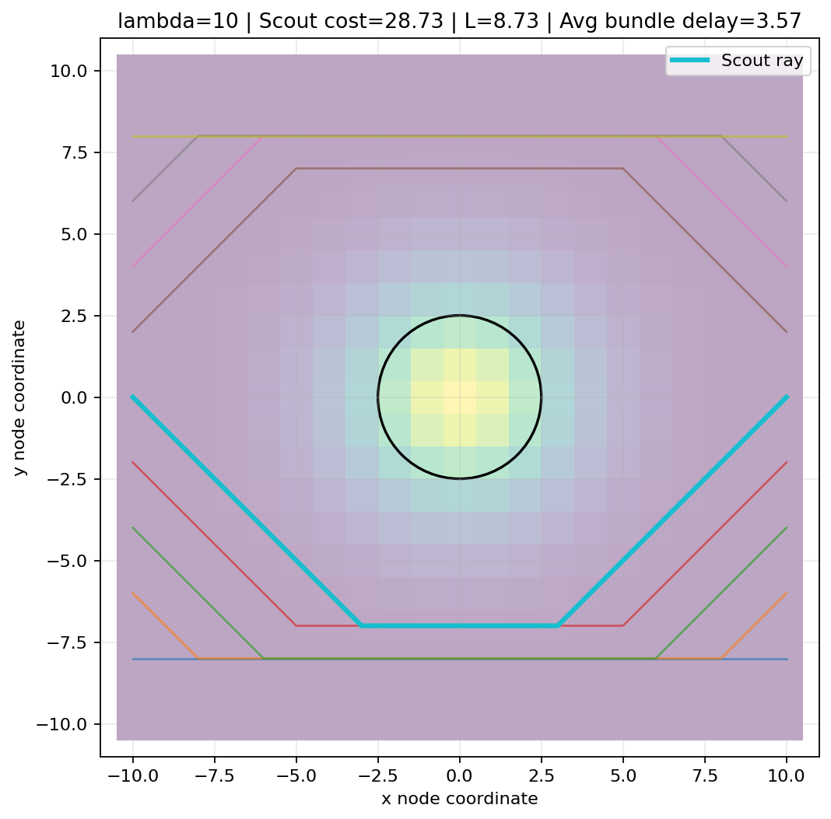
Figure 1. Scalar delay case. High delay produces detour/wall-like behaviour rather than controlled focusing.

5. Toy Model 1D-B: Scalar Connectivity and Failure Mode
The next test added scalar connectivity compression. The idea was that a high-density relational region might reduce effective distance because it contains more local relational connection.
c_ij = c0_ij * [1 + lambda Rbar_ij] / [1 + mu Rbar_ij]

The numerator increases cost through delay. The denominator reduces cost through connectivity compression. This produced inward convergence, but if mu dominated too strongly it created a shortcut/wormhole-like effect rather than a physically acceptable lensing analogue.
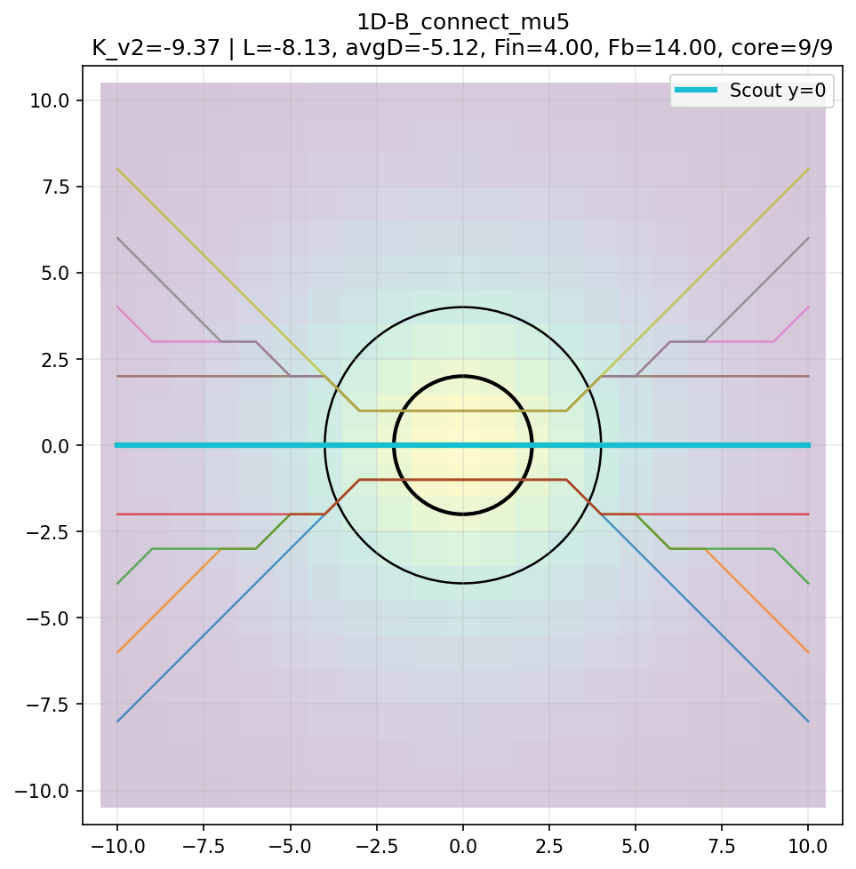
Figure 2. Scalar connectivity failure mode. Pure connectivity can over-reward central shortcuts and behave like a wormhole analogue.

6. Toy Model 1D-C: Directional Rules
The key correction was that scalar rules were too blunt. They treat all directions equally. A geometry-like model needs direction. This led to vectorial and directional rules based on alignment between the edge direction and the local radial or gradient direction.

6.1 Dot product and direction
The dot product measures how aligned two directions are.
dot = e_hat dot g_hat
If dot = 1: directions are aligned.
If dot = 0: directions are perpendicular.
If dot = -1: directions are opposite.

The model used the squared dot product so inward and outward radial movement are treated symmetrically. This keeps the edge rule closer to a direction-dependent metric rule instead of a one-way pull.
(e_hat dot g_hat)^2

6.2 C3 inverted-radii rule
After several intermediate tests, the best structure was an inverted-radii C3 rule: a wide scalar baseline delay, a wide vectorial connectivity field, and a tight radial delay field around the core.
c_ij =
c0_ij *
[1 + lambda0 R_lambda0 + lambda_r R_lambdar (e_hat dot r_hat)^2]
/
[1 + mu R_mu (e_hat dot g_hat)^2]

Meaning:
- lambda0 R_lambda0 = wide general operational delay.
- lambda_r R_lambdar (e_hat dot r_hat)^2 = tight radial core penalty.
- mu R_mu (e_hat dot g_hat)^2 = wide directional connectivity compression.
- The wide connectivity field can capture paths early.
- The tight radial delay prevents uncontrolled collapse into the core.

7. Static Calibration and K_V42 v2
The static calibration stage was necessary because earlier scoring functions rewarded visually attractive but physically suspect shortcut behaviour. The K_V42 diagnostic was therefore revised to reward focusing while also requiring operational friction.
The final diagnostic was not a physical curvature scalar. It was an engineering-style comparison tool.
K_V42 v2 rewards:
- inward focusing
- bundle convergence
- positive operational delay
K_V42 v2 penalizes:
- negative delay / shortcut behaviour
- excess core collapse
- boundary fleeing
- weak focusing
- excessive over-delay

7.1 Best calibrated static candidate
C3_tuned_l03_lr12_mu6
lambda0 = 3
lambda_r = 12
mu = 6
rho0 = 4
rhor = 2
rhom = 4

Metric | Result
K_V42 v2 | 5.07
Scout delay L | +3.07
Average bundle delay | +3.31
F_in | 1.75
F_bundle | 4.00
Core paths | 3/9
Boundary paths | 0/9
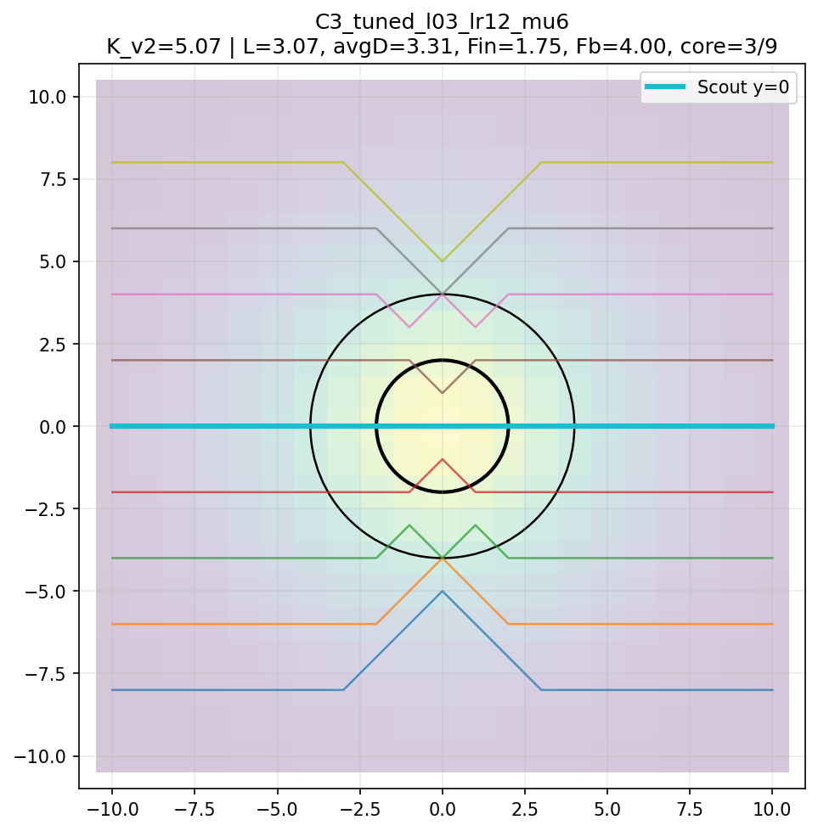
Figure 3. Best calibrated static candidate: C3_tuned_l03_lr12_mu6. The case balances inward focusing, positive delay, limited core entry, and no boundary fleeing.

8. Dynamic Orbit Test v0
After static calibration, the next question was whether the calibrated field could be converted into a simple dynamic analogue. This required a new modelling class. A static Dijkstra shortest-path model does not itself contain velocity, time stepping, or momentum. Therefore, the dynamic orbit test introduced an explicit toy radial potential.

8.1 Dynamic potential
U(r) = lambda0 R0(r) + lambda_r Rr(r) - mu Rm(r)

Meaning:
- U(r) = effective radial potential.
- lambda0 R0(r) = wide delay resistance.
- lambda_r Rr(r) = tight radial core resistance.
- mu Rm(r) = wide connectivity attraction.
- The minus sign before mu means connectivity lowers the effective potential.

8.2 Update law
a = -grad(U)

Meaning:
- a = acceleration vector of the test particle.
- grad(U) = gradient of the potential, meaning the direction and rate of steepest increase.
- -grad(U) means the particle accelerates toward lower effective potential.
- The particle also keeps momentum through time stepping.
This is not the geodesic equation of General Relativity. It is a toy force/potential analogue derived from the calibrated radial profiles.
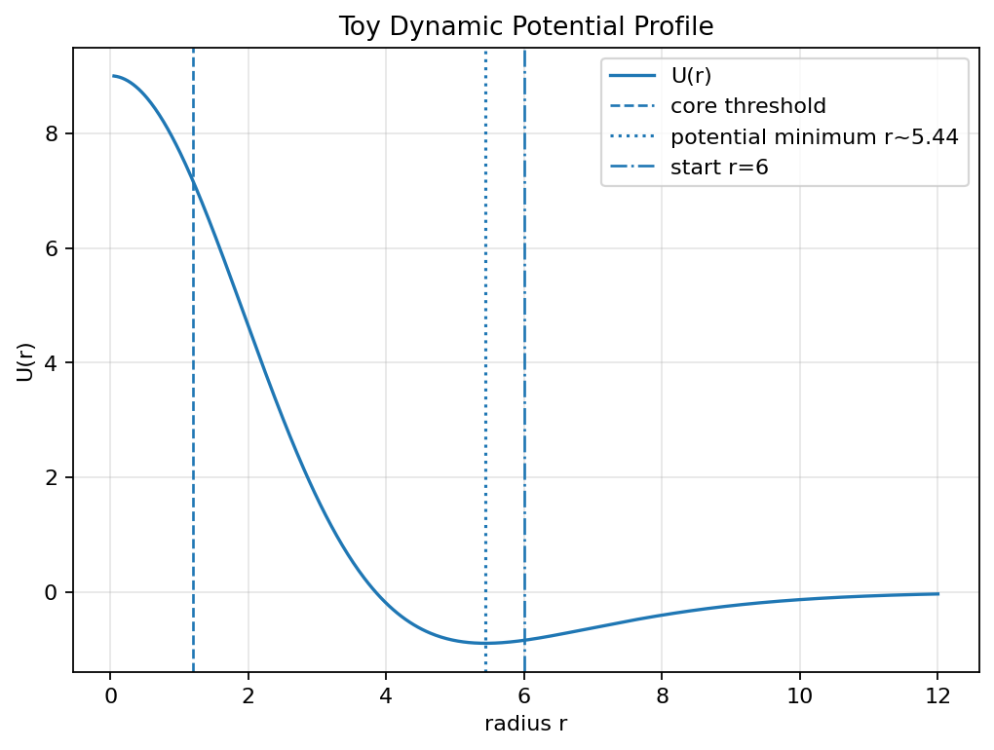
Figure 4. Toy dynamic potential profile used for the orbit test. The profile was derived from the calibrated C3 radial fields.

8.3 Velocity sweep result
Initial velocity v0 | Classification | Radius range | Turns
0.40 | elliptical bounded | variable bounded | multiple
1.00 | near-circular bounded | 5.999 - 6.011 | 7.94
1.40 | elliptical bounded | variable bounded | multiple
1.60 | escape | left bounded region | N/A
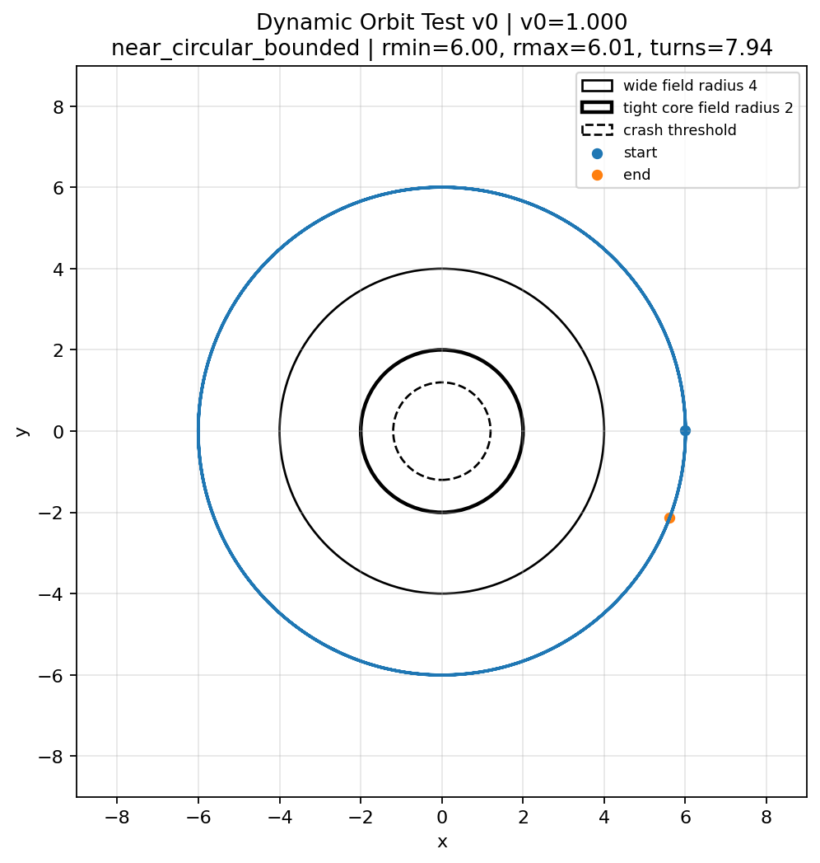
Figure 5. Dynamic orbit test v0. Initial velocity v0 = 1.00 produced a near-circular bounded trajectory.
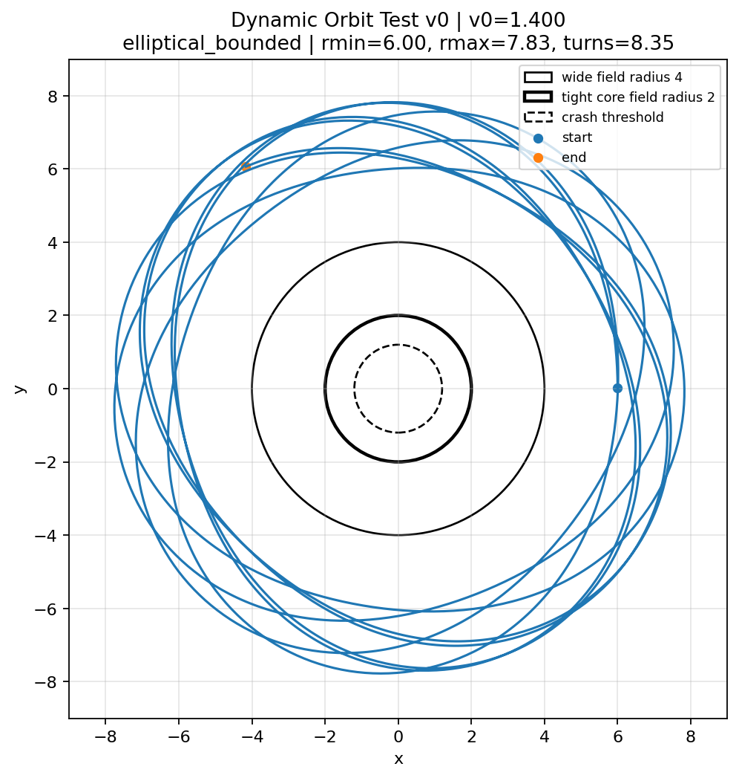
Figure 6. Dynamic orbit test v0. Initial velocity v0 = 1.40 produced a bounded elliptical-type trajectory.

9. Close-Out Result
The V4.2 Toy Model 1D track is complete as an exploratory toy-model milestone.
The close-out statement is:
The Toy Model 1D track successfully produced a mathematically explicit graph-based operational analogue of geometry emerging from relational organization.
The model generated controlled analogues of:
- operational delay
- path focusing
- bounded dynamic motion
This supports Relationship -> Organization -> Observable Order in the limited sense that defined relational rules can generate graph-based path behaviours analogous to selected gravity-like behaviours.

9.1 What was actually achieved
- A local source field was defined mathematically.
- Edge traversal costs were modified by scalar, vectorial, and directional terms.
- Static path bundles showed delay, detour, focusing, and calibrated balanced behaviour.
- A best static candidate was found through autonomous calibration.
- A toy dynamic potential based on the calibrated radial fields produced bounded circular and elliptical-type trajectories.

10. Limitations and Non-Claims
The following are explicitly not claimed:
- The model does not derive General Relativity.
- The model does not derive Einstein's field equations.
- The model does not prove spacetime curvature.
- The model does not prove physical gravity.
- The model does not reproduce observed gravitational lensing data.
- The model does not recover known GR orbital equations.
- The dynamic update law is not the GR geodesic equation.
- The K_V42 index is not Ricci curvature, scalar curvature, or a standard graph-curvature theorem.
The model is best understood as a working mathematical scaffold. It shows that the framework has a non-trivial operational pathway, but the physics remains to be proven or falsified through later formalization.

11. Next Chapter
With the Toy Model 1D chapter closed, the next chapter should not simply add more simulation output. The next step should become more formal.
Recommended next chapter options:
- Define a formal graph-curvature measure and compare it with known graph curvature notions such as Ollivier-Ricci and Forman-Ricci curvature.
- Translate the operational cost rule into a tensor-like local metric object rather than an edge-by-edge cost rule.
- Test recovery of known limiting behaviours, beginning with simple weak-field expectations.
- Develop a falsifiability roadmap: identify what output would disagree with the framework or distinguish it from standard interpretations.
- Begin Toy Model 2 on quantum-side behaviour, such as hidden relational proximity and entanglement-like correlation, with strict no-signalling guardrails.
R Twin recommendation: the next chapter should be either a formal graph-curvature bridge or a metric-tensor bridge. The orbit test is useful, but without a metric or curvature definition it remains a visually convincing toy simulation rather than a formal physics bridge.

Appendix A. Formula Legend
Symbol / Formula | Meaning
R_i = R0 exp(-r_i^2 / (2 rho^2)) | Gaussian record-density source field.
c_ij | Modified edge cost between node i and node j.
c0_ij | Flat baseline edge cost.
lambda0 | Wide scalar/general delay strength.
lambda_r | Tight radial delay strength.
mu | Vectorial connectivity strength.
e_hat | Unit vector along the edge direction.
r_hat | Unit radial vector away from the centre.
g_hat | Unit gradient vector toward higher source density.
(e_hat dot r_hat)^2 | Directional radial delay alignment factor.
(e_hat dot g_hat)^2 | Directional connectivity alignment factor.
U(r) | Toy dynamic radial potential.
a = -grad(U) | Toy update law: acceleration toward lower potential.

Appendix B. Numerical Summary
Best static calibration result:
C3_tuned_l03_lr12_mu6
K_V42 v2 = 5.07
Scout delay L = +3.07
Average bundle delay = +3.31
F_in = 1.75
F_bundle = 4.00
Core paths = 3/9
Boundary paths = 0/9

Best dynamic orbit v0 result:
Initial position = (6, 0)
Initial velocity = (0, 1.0)
Classification = near-circular bounded
rmin = 5.999
rmax = 6.011
turns = 7.94

End of V4.2 Toy Model 1D Close-Out Paper - Rev A

